

Neil Chester
Designer & Illustrator
23 Edward Bailey Close, Coventry,
West Midlands. CV32LZ

Qualified freelance service providing innovative, effective design solutions from a fresh perspective, every time.

Several years of experience working independently and within teams. A dedicated and flexible individual with drive and ambition to face challenges and develop existing skills.
Currently supporting events and local businesses with print and online graphic campaign development. Previous expertise attained in strong pitch, communication and finishing framework.
Actively pursuing a more rewarding and permanent role,
promoting self-expression and future opportunities.


Legacy Cheer and Dance ltd
Croydon, London. CR0 1AA
Event merchandise + award design
Neon Martian
Swindon, Wiltshire. SN25 4TX
Ecommerce web artwork + project management
2022

2016

2016

2015

2013-14

2011-13

2012-13

2007-09
Obsidian Content
Wolverhampton, West Midlands. WV38AD
Concept to final flyer + professional stationery

Express Design + Print
Wolverhampton, West Midlands. WV22RH
Re-brand concept to final web + print campaign

Major Reaction Design & Print
Wolverhampton, West Midlands. WV14DJ
Multiple concept to final web + print campaigns

The Whiskey Syndicate
I.a.t.Eye Records, Armthorpe, Doncaster. DN33HZ
Digital manipulation/illustration print campaign

Company Creative Haircutting
Coventry, West Midlands. CV57FW
Advertising website design + copywriting

The OASIS
Birmingham, West Midlands. B46SX
Re-brand concept to final identity campaign

many more between and prior.

Aly Calvo. aly@legacycheeranddance.com
Legacy Cheer and Dance ltd

Jenni Lowe. jenii@obsidiancontent.co.uk
Obsidian Content Creation

077 6060 7070
neilchester.co.uk /portfolio.pdf
info@neilchester.co.uk
uk.linkedin.com/in/neilchester

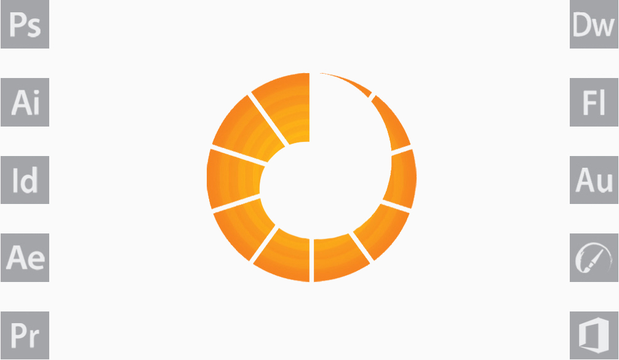
Photoshop
Illustrator
In Design
After Effects
Premiere

Dream Weaver
Flash
Audition
Rebelle
Microsoft Office

Traditional hand-drawn illustration

Raster digital illustration

Corporate logo & identity

Advertising products + signage

Copywriting

Vector digital illustration

Hand engraving

Mount, pitch + exhibition

Hardware maintenance

Video editing, resolution + codec

CMS, CSS + HTML front-end
Bachelor of Arts – Animation with honours 2.1
University of Wolverhampton
Wulfruna St, Wolverhampton. WV1 1LY

GNVQ Advanced Art & Design - 12 Unit: Distinction
I.T. Key skills - Microsoft Office + Adobe Creative Suite
City Technology College - Kingshurst, Birmingham. B37 6NU

Personal responsibilities and achievements
Bring and Buy Officer and senior crew member; charity
event budget, service and staff supervision.
Ewan Chrystal Award 2013 charity + community support.

